|  |
| --- |
|  |
| **Mentor Messenger**  October 2017 |
|  |
|  |
| Great teachers empathize with kids, respect them, and believe that each one has something special that can be built upon.  **-Ann Lieberman** |
|  |

The Disillusionment Phase!

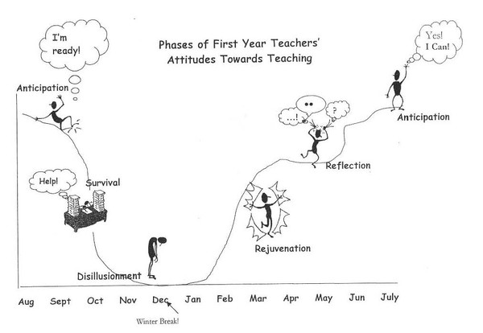



|  |
| --- |
|  |
| During the third month… -Look at [MyPGS](https://washoe.truenorthlogic.com/U/P/Channel/-/Guest/Login) to sign up for a professional learning class.  -Incorporate feedback from your post observation conference into your lesson planning.  -Review [Nevada Academic Content Standards (NVACS)](http://www.doe.nv.gov/Standards_Instructional_Support/Nevada_Academic_Content_Standards/) and your assessments to ensure alignment. School specific things to know… -What support staff does my school have (Academic Coach, Dept. Lead, Implementation Specialist, MTSS team, SEL team, counselors, 21st Century Learning)?  -What are the expectations for conference week (Elementary schools only)?  -What are the expectations for sending work home with students over Fall Break? |
|  |

**Disillusionment Phase:** After weeks of nonstop work and stress, new teachers enter the disillusionment phase. The intensity and length of the phase varies among new teachers. The extensive time commitment, the realization that things are probably not going as smoothly as they want and low morale contribute to this period of disenchantment. New teachers begin questioning both their commitment and their competence. Many new teachers get sick during this phase. During this phase, classroom management is a major source of distress. At this point, the accumulated stress of the first-year teachers, coupled with months of excessive time allotted to teaching, often brings complaints from family members and friends. This is a very difficult and challenging phase for new entries into the profession. They express self-doubt, have lower self-esteem and question their professional commitment. In fact, getting through this phase may be the toughest challenge they face as a new teacher.

**Setting High Expectations for Student Engagement**

Time is a valuable resource in the classroom. Sometimes if feels like there is never enough time to teach everything! So, how do we make the most of the time that we have? Ensure student engagement!

Take Time to Plan Student Engagement in Your Lessons:

* Model and expect active listening from students (eyes on speaker, upright sitting posture)
* Balance the interaction between whole class, small group, and individual learning time in your planning
* Set up a procedure for ensuring ALL students are called on in discussions
* Plan to pause every 8 to 10 minutes of instructional time to allow student to process. Plan ahead for how they will process (i.e. turn and share with a partner, write notes on the content, etc.)
* Plan 3-5 seconds of wait time after posing a question.

The more carefully you plan student engagement into your lessons, the more students will stay on task and actively involved in their learning. Have you considered how students will interact with each piece of your content? Is the expectation that 100% of students will be engaged clear to the students? Data on student engagement can be very helpful! Ask your Consulting Teacher (CT) to help you collect data on how many students are engaged during a lesson. Then think about what strategies could help ensure that 100% of students are engaged!

**Check out this cute video with two second year teachers giving advice!**

<http://video.edweek.org/detail/video/5574068218001/second-year-teachers-share-some-advice-for-rookies?autoStart=true&cmp=eml-enl-vid-p3>

***Take A Minute and Check It Out:***

**Use a QR Code:**

**Mentoring and Induction Website My PGS Registration**





**Join us on Pinterest at: WCSD Mentoring Program**